OS Assignment

NAME
REG NO
BRANCH AND SEC

EXPERIMENT 3A – MULTITHREADING AND PTHREADS IN C – SINGLE PROCESSOR
Multithreading and Pthreads in C – AR/VR Video Management
Aim:
To implement multithreading using POSIX threads (P threads) in C and demonstrate concurrent execution of tasks in an AR/VR video management system.
Algorithm:
Step 1: Start the program.
Step 2: Define two functions for loading and processing AR/VR video frames.
Step 3: Create two threads using the pthread_create() function.
Step 4: Execute the video loading and video processing tasks using the two threads.
Step 5: Wait for both threads to complete using the pthread_join() function.
Step 6: Display the completion message and terminate the program.
Program:
#include <stdio.h>
#include <pthread.h>
int slots=4; pthread_rwlock_t l=PTHREAD_RWLOCK_INITIALIZER;
void *read(void *p){pthread_rwlock_rdlock(&l);printf("Slots: %d\n",slots);pthread_rwlock_unlock(&l);return 0;}
void *write(void *p){pthread_rwlock_wrlock(&l);slots--;printf("Updated: %d\n",slots);pthread_rwlock_unlock(&l);return 0;}
int main(){pthread_t r,w;pthread_create(&r,0,read,0);pthread_create(&w,0,write,0);
pthread_join(r,0);pthread_join(w,0);return 0;}
Program output:
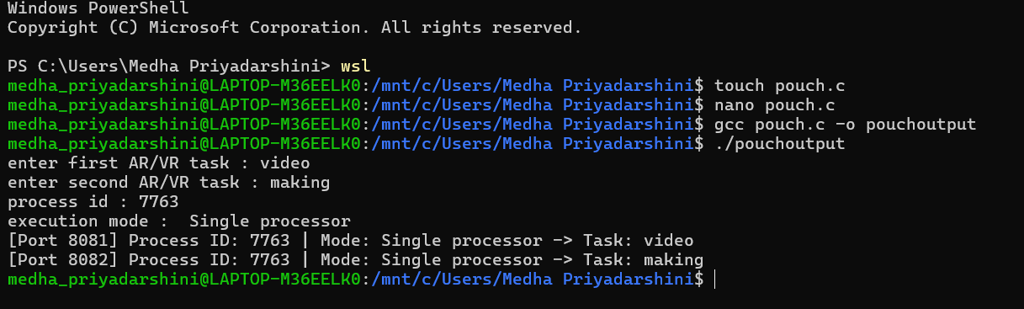
Definitions:
Multithreading: A technique in which multiple threads execute within the same process.
Thread: The smallest unit of execution within a process.
Pthread: The POSIX thread library used for creating and managing threads in C.
pthread_create(): A function used to create a new thread.
pthread_join(): A function used to wait for a thread to complete its execution.
Domain and Use Case
Domain: AR/VR Systems and Multimedia Processing
Use Case: AR/VR Video Management
Real-World Application: AR/VR applications load and process video frames to provide interactive and immersive content. These tasks can be handled concurrently using multiple threads.
Practical Application: One thread can handle loading or capturing AR/VR frames while another thread processes the frames for display.
Where Exactly It Is Used: This concept can be applied in software running on computers or AR/VR headsets where video frames need to be loaded and processed concurrently

EXPERIMENT 3B – MULTITHREADING AND PTHREADS IN C – MULTIPROCESSOR
Multithreading and Pthreads in C – Multiprocessor
Aim:
To implement multithreading using POSIX threads (Pthreads) in C and demonstrate parallel execution of tasks on multiple processors using an EV charging system.
Algorithm:
Step 1: Start the program and define the EV charging tasks.
Step 2: Create multiple threads using pthread_create().
Step 3: Assign different charging tasks to the threads.
Step 4: Execute the tasks concurrently on multiple processors.
Step 5: Wait for all threads using pthread_join().
Step 6: Display the completed charging tasks and terminate the program.
Program:
#include <stdio.h>
#include <pthread.h>
void *charge(void *p){printf("Charger %d: EV charging\n",*(int*)p);return 0;}
int main(){pthread_t t1,t2;int a=1,b=2;
pthread_create(&t1,0,charge,&a);pthread_create(&t2,0,charge,&b);
pthread_join(t1,0);pthread_join(t2,0);
printf("EV charging tasks completed\n");return 0;}
Program Output:
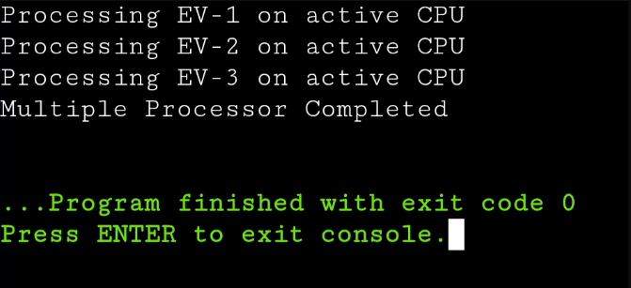
Definitions:
Multithreading: A technique in which multiple threads execute within the same process.
Pthread: The POSIX thread library used for creating and managing threads in C.
Thread: The smallest unit of execution within a process.
Multiprocessor: A computer system containing two or more processors that can execute tasks in parallel.
Parallel Execution: The simultaneous execution of multiple tasks using multiple processing units.
pthread_create(): A function used to create a new thread.
pthread_join(): A function used to wait for a thread to complete its execution.
Domain and Use Case
Domain: Electric Vehicle Infrastructure and Smart Transportation
Use Case: EV Charging
Real-World Application: EV charging stations may manage multiple charging points simultaneously. Multithreading allows software to handle charging tasks from different charging points concurrently.
Practical Application: Separate threads can monitor and manage charging operations for different EVs at the same time.
Where Exactly It Is Used: This concept can be applied in EV charging-station controllers and backend systems that manage multiple charging points simultaneously.

EXPERIMENT 4 A– MUTUAL EXCLUSION USING SEMAPHORE AND MONITOR
Aim:
To implement and demonstrate mutual exclusion using a semaphore and monitor mechanism in C, ensuring safe access to a shared resource by multiple threads.
Algorithm:
Step 1: Start the program and initialize the semaphore and shared resource.
Step 2: Create two threads to access the shared resource.
Step 3: Use the semaphore to allow only one thread to enter the critical section.
Step 4: Use a mutex to provide monitor-based mutual exclusion.
Step 5: Update the shared resource and release the synchronization locks.
Step 6: Wait for all threads, display the final value, and terminate the program.
Program:
#include <stdio.h>
#include <pthread.h>
#include <semaphore.h>
int x=0; sem_t s; pthread_mutex_t m=PTHREAD_MUTEX_INITIALIZER;
void *work(void *p){ sem_wait(&s); pthread_mutex_lock(&m); x++; printf("Thread %d: x=%d\n",*(int*)p,x); pthread_mutex_unlock(&m); sem_post(&s); return NULL; }
int main(){ pthread_t t1,t2; int a=1,b=2; sem_init(&s,0,1);
pthread_create(&t1,NULL,work,&a); pthread_create(&t2,NULL,work,&b);
pthread_join(t1,NULL); pthread_join(t2,NULL);
printf("Final value=%d\n",x); sem_destroy(&s); pthread_mutex_destroy(&m);
return 0; }
Program Output :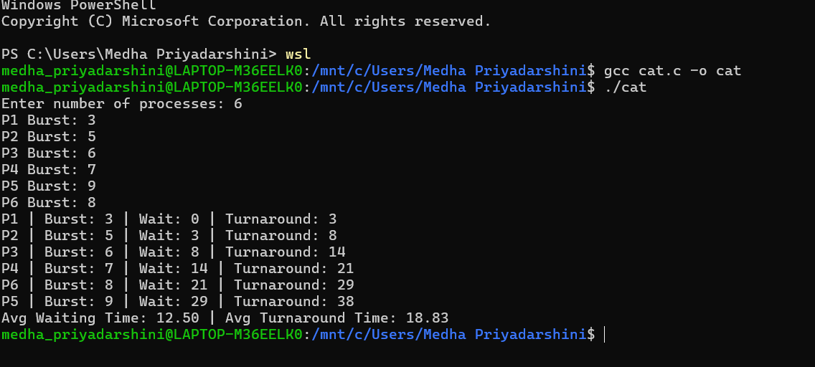
.
Definitions:
Mutual Exclusion: A mechanism that allows only one thread to access a critical section at a time.
Semaphore: A synchronization mechanism used to control access to shared resources.
Monitor: A synchronization mechanism that provides controlled access to shared data.
Critical Section: The part of a program where a shared resource is accessed or modified.
Mutex: A lock used to provide mutual exclusion between threads.
Thread: The smallest unit of execution within a process.
Domain and Use Case:
Domain: Banking and Financial Transaction Systems
Use Case: Concurrent Bank Account Transactions
Real-World Application: Multiple banking transactions may attempt to update the same account balance simultaneously. Mutual exclusion prevents conflicting updates and maintains consistent account information.
Where Exactly It Is Used: This concept is used in banking servers and transaction-processing software where multiple threads access shared customer account data.

EXPERIMENT 4B – SEMAPHORE SYNCHRONIZATION
Semaphore Synchronization – Autonomous Warehouse Robots
Aim:
To implement semaphore synchronization in C and demonstrate controlled access to a shared resource in an autonomous warehouse robot system.
Algorithm:
Step 1: Start the program and initialize the semaphore.
Step 2: Create threads representing warehouse robots.
Step 3: Allow one robot at a time to access the shared resource.
Step 4: Use sem_wait() before accessing the resource.
Step 5: Use sem_post() after completing the operation.
Step 6: Wait for all robots and terminate the program.
Program:
#include <stdio.h>
#include <pthread.h>
#include <semaphore.h>
sem_t s;
void *robot(void *p){sem_wait(&s);printf("Robot %d using station\n",*(int*)p);sem_post(&s);return 0;}
int main(){pthread_t t1,t2;int a=1,b=2;sem_init(&s,0,1);
pthread_create(&t1,0,robot,&a);pthread_create(&t2,0,robot,&b);
pthread_join(t1,0);pthread_join(t2,0);sem_destroy(&s);return 0;}

Program Output:
Definitions:
Semaphore: A synchronization mechanism used to control access to shared resources.
Synchronization: Coordination of multiple threads to ensure safe execution.
Critical Section: The section of code where a shared resource is accessed.
sem_wait(): Waits for and acquires the semaphore.
sem_post(): Releases the semaphore.
Thread: The smallest unit of execution within a process.
Domain and Use Case
Domain: Industrial Automation and Warehouse Robotics
Use Case: Autonomous Warehouse Robots
Real-World Application: Multiple autonomous robots may need to use the same charging station, loading point, or conveyor section. A semaphore can control access so that conflicting operations do not occur simultaneously.
Where Exactly It Is Used: This concept can be applied in warehouse control software that coordinates autonomous robots and shared stations.

EXPERIMENT 4C – MONITOR SYNCHRONIZATION – SATELLITE WEATHER DATABASE
Monitor Synchronization – Satellite Weather Database
Aim:
To implement monitor-based synchronization using a mutex in C and demonstrate safe access to a shared satellite weather database.
Algorithm:
Step 1: Start the program and initialize the shared weather data.
Step 2: Create threads representing weather-data processing tasks.
Step 3: Use a mutex to provide monitor-based mutual exclusion.
Step 4: Allow one thread at a time to update the shared weather data.
Step 5: Release the mutex after completing the update.
Step 6: Wait for all threads, display the final data, and terminate.
Program:
#include <stdio.h>
#include <pthread.h>
int data=25; pthread_mutex_t m=PTHREAD_MUTEX_INITIALIZER;
void *update(void *p){pthread_mutex_lock(&m);data+=5;printf("Weather data: %d\n",data);pthread_mutex_unlock(&m);return 0;}
int main(){pthread_t t1,t2;
pthread_create(&t1,0,update,0);pthread_create(&t2,0,update,0);
pthread_join(t1,0);pthread_join(t2,0);printf("Final data: %d\n",data);
pthread_mutex_destroy(&m);return 0;}

Program Output:

Weather data: 30
Weather data: 35
Final data: 35
The order of thread execution may vary.
Definitions
Monitor: A synchronization mechanism that provides controlled access to shared data.
Mutex: A lock that allows only one thread to access a critical section at a time.
Mutual Exclusion: A mechanism that prevents simultaneous access to a shared resource.
Shared Data: Information accessed or modified by multiple threads.
Critical Section: The part of a program where shared data is accessed or modified.
Thread: The smallest unit of execution within a process.
Domain and Use Case
Domain: Satellite Systems and Weather Data Processing
Use Case: Satellite Weather Database
Real-World Application: Weather satellites continuously collect information such as temperature and atmospheric conditions. Multiple processing tasks may access and update the same weather database.
EXPERIMENT 5 – READERS-WRITERS PROBLEM
Readers-Writers Problem – EV Charging Station

Aim:
To implement the Readers-Writers synchronization problem using Pthreads and demonstrate concurrent reading and exclusive writing in an EV charging station management system.
Algorithm:
Step 1: Start the program and initialize the available EV charging slots.
Step 2: Create reader threads to read the available slot information.
Step 3: Create a writer thread to update the charging slot information.
Step 4: Use a read-write lock to control access to the shared data.
Step 5: Allow multiple readers while providing exclusive access to the writer.
Step 6: Wait for all threads and terminate the program.
Program:
#include <stdio.h>
#include <pthread.h>
int slots=4; pthread_rwlock_t lock=PTHREAD_RWLOCK_INITIALIZER;
void *reader(void *p){pthread_rwlock_rdlock(&lock);printf("Available EV slots: %d\n",slots);pthread_rwlock_unlock(&lock);return NULL;}
void *writer(void *p){pthread_rwlock_wrlock(&lock);slots--;printf("Charging started, slots: %d\n",slots);pthread_rwlock_unlock(&lock);return NULL;}
int main(){pthread_t r1,r2,w;
pthread_create(&r1,NULL,reader,NULL);pthread_create(&r2,NULL,reader,NULL);pthread_create(&w,NULL,writer,NULL);
pthread_join(r1,NULL);pthread_join(r2,NULL);pthread_join(w,NULL);
return 0;}

Program Output:
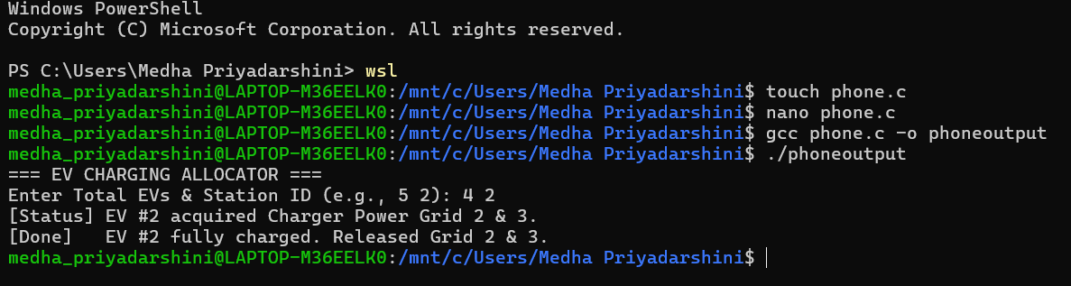Definitions:
Readers-Writers Problem: A synchronization problem involving multiple readers and writers accessing shared data.
Reader: A thread that reads shared data without modifying it.
Writer: A thread that modifies shared data.
Read Lock: A lock that allows multiple readers to access shared data simultaneously.
Write Lock: A lock that provides exclusive access to shared data.
pthread_rwlock_t: A POSIX read-write lock used for synchronizing readers and writers.
Domain and Use Case
Domain: Electric Vehicle Infrastructure and Smart Transportation
Use Case: EV Charging Station Management
Real-World Application: An EV charging station maintains information about available charging slots. Multiple users or systems may read this information while a charging request may modify the available-slot count.
Where Exactly It Is Used: This concept can be applied in charging-station controllers and backend software that manages multiple EV charging points.
EXPERIMENT 6 – DINING PHILOSOPHERS PROBLEM
Dining Philosophers Problem – Drones Relay Packets Using Shared Links
Aim:
To implement the Dining Philosophers synchronization problem using mutexes in C and demonstrate controlled access to shared communication links by drones.
Algorithm:
Step 1: Start the program and initialize the shared communication links.
Step 2: Create threads representing the drones.
Step 3: Assign two shared links to each drone for packet transmission.
Step 4: Use mutex locks to control access to the shared links.
Step 5: Allow a drone to relay a packet only when the required links are available.
Step 6: Release the links, wait for all threads, and terminate the program.
Program:
#include <stdio.h>
#include <pthread.h>
pthread_mutex_t l[5];
void *drone(void *p){int i=*(int*)p;if(!pthread_mutex_trylock(&l[i])){printf("Drone %d relayed packet\n",i);pthread_mutex_unlock(&l[i]);}return 0;}
int main(){pthread_t t[5];int i,id[5]={0,1,2,3,4};
for(i=0;i<5;i++)pthread_mutex_init(&l[i],0);
for(i=0;i<5;i++)pthread_create(&t[i],0,drone,&id[i]);
for(i=0;i<5;i++)pthread_join(t[i],0);return 0;}
Program-output :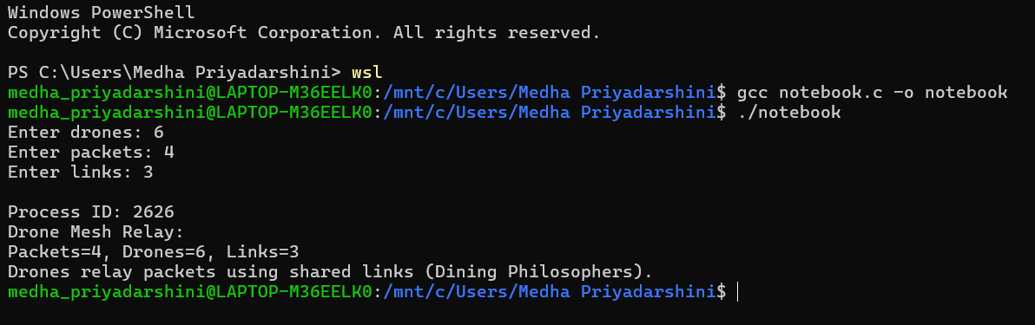

Definitions:
Dining Philosophers Problem: A classic synchronization problem used to demonstrate competition for shared resources.
Thread: The smallest unit of execution within a process.
Mutex: A synchronization mechanism that allows only one thread to access a shared resource at a time.
Shared Resource: A resource that can be accessed by multiple threads.
Deadlock: A situation where threads wait indefinitely for resources held by one another.
pthread_mutex_trylock(): A function that attempts to acquire a mutex without waiting indefinitely.
Domain and Use Case:`
Domain: Drone Communication and Wireless Networking
Use Case: Drones Relay Packets Using Shared Links
Real-World Application: Multiple drones in a communication network may need to use shared communication links to relay data packets. Synchronization prevents multiple drones from accessing the same link at the same time.
Practical Application: Each drone can acquire the required communication links before transmitting or relaying a packet.
Where Exactly It Is Used: This concept can be applied in drone communication-control software where multiple drones compete for shared wireless communication resources.

